Barguna District,Bangladesh
(Established as a district: 28th Feb,1984)
N
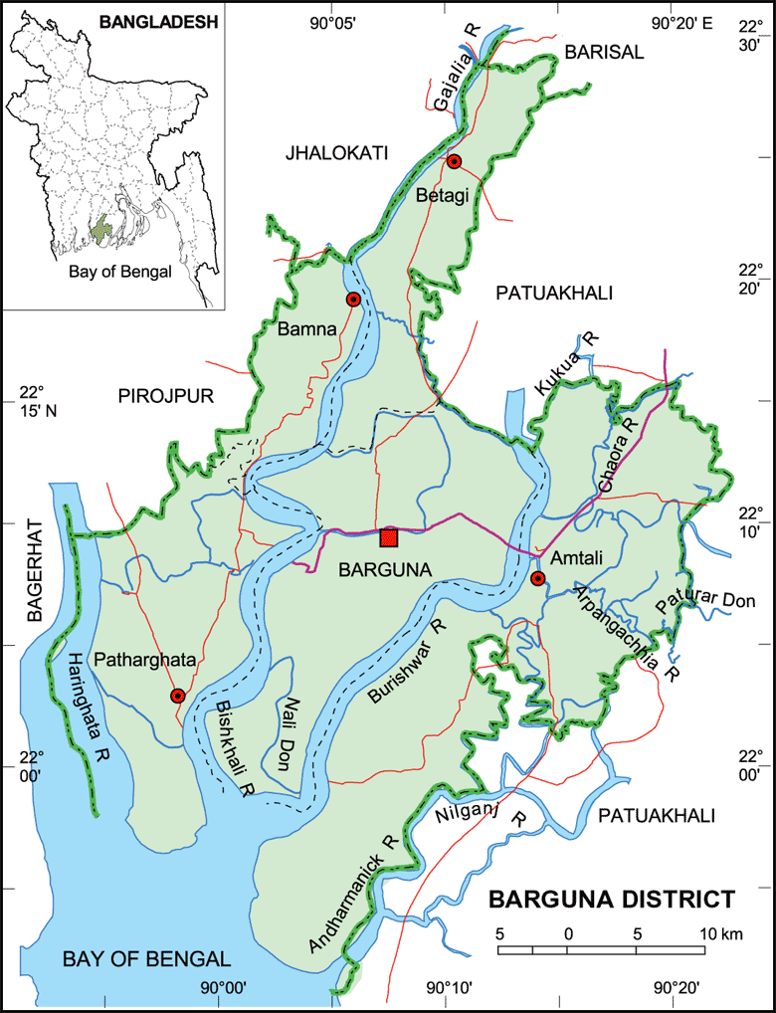
S
Fig-1: Map of Barguna District

Visit Report: Civil Surgeon Office, Barguna
Date of Visit: 23/08/22; Time: 9:30 AM.
Visitor: Md. Abdul Hakim Mazumdar, National Consultant (HEU),
Dr. Md. Emdadul Haque, National Consultant (HEU)
Md. Shamsur Rahman, Junior National Consultant (HEU) &
Dr. Nazmur Rahman Sajib, Junior National Consultant (HEU)

1. We arrived at 9:30 am in the Civil Surgeon Office, Barguna. We discussed with the Civil Surgeon and Deputy Civil Surgeon about the overall health service system of the district.
2. We also discussed with them about the SSK program and role of the District Hospital and Upazila Health Complexes as well as the role of the health service providers in SSK.
3. The Civil Surgeon was very cordial and he has ensured us to provide necessary support to implement SSK services.

Barguna District Profile:
Total population: 10,55,171
Upazilla: 6 Powroshova: 3 Union: 42

1. Sadar Hospital: 100 bedded.
2. Upazilla Health complex: 6 (5 of them are 50 Bedded, Taltoli-20 Bedded)
3. Community Clinic: 129
4. Rural Dispensary: 08
5. HFWC: 23

Status in HSS Score From Jan-July:
Name | Janu | Feb | Mar | April | May | June | July
Barguna D-Hospi | 03 | 07 | 19 | 22 | 21 | 16 | 19
Amtoli UHC | 319 | 200 | 255 | 298 | 207 | 368 | 353
BetagiUHC | 306 | 314 | 304 | 332 | 340 | 337 | 341
BamnaUHC | 221 | 162 | 290 | 230 | 279 | 277 | 279
PathorghataUHC | 209 | 291 | 347 | 258 | 248 | 270 | 385
Taltoli UHC | - | - | - | - | - | - | -
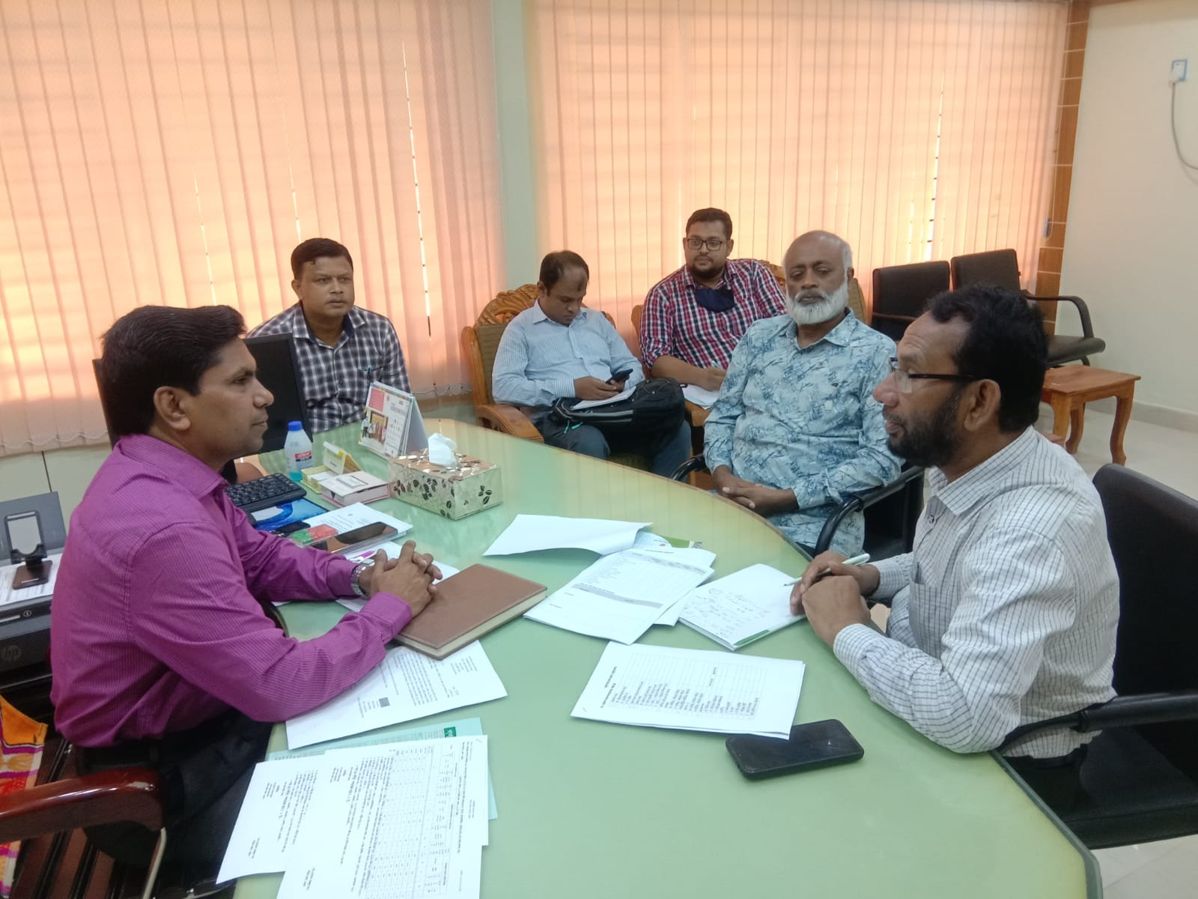

Fig-2: Meeting with Civil Surgeon, Barguna

